**Home**

**Database**

Chua, Royce B.

Cinco, Patrick Jay

Estepa, Kristoffer Bryant

Padron, Christian Adrian A.

Real, Elson Paul

**Background**

In the past, remembering to do chores wasn’t a tedious thing to do but with the progress and breakthroughs in technology, the world has entered into a new era, the Information/Computer Age. Today, technology now plays a crucial role in almost every aspect of our lives, from communication, transportation, health, daily activities, and more, we cannot deny that the world has become a much busier place than it was before. Because of this “busy-ness” trend, managing the home for the average family has become somewhat harder to do due to the office work being extended to the home place through computers (smartphones and personal computers). People’s lifestyles have changed to be more hectic with increased workload because of technology as mentioned in an article by the Telegraph.

With the world now in the Technology age, it is no surprise that once in a while family members do tend to forget their respective tasks in their homes because of the many tasks at work or at schools for kids and the array of gadgets at their disposal, from smartphones to Xbox or PlayStation console, to the desktop pc or laptop that keeps us preoccupied and sometimes unaware of the time. To further add on the issue of forgetting chores, in an article by the Telegraph, adults tend to forget three things everyday according to a study. The article said that people tend to forget “PIN numbers, passwords and chores such as taking food out of the freezer the night before and charging your mobile phone”. We could include children in this trend also since they themselves are being hooked on technology and are becoming busy on things like Facebook, Instagram, watching movies, and playing video games. Forgetting to do a certain house task or chore is certainly no one wants intentionally do but often times it is a common sight in households everywhere.

**Statement of the Problem**

The problem that the program aims to be solve is the problem of family members or individuals forgetting about their tasks at home because of busy schedules.

**General Objectives**

The following are the general objectives of the program

* To assist in providing the accomplishment of the entire user’s planned work through the development of a task management system for a family members or individuals to be able to keep track of their tasks and its deadlines.
* For a parent:
  + Being able to command their child in a hi-tech way.
* For a child:
  + Being able to know if there is such a command given by their parent with the use of technology and its schedule.
* For an individual
  + Being able to monitor his or her task that is scheduled.

**Specific Objectives:**

The following are the objective features for the system to have:

* A database system that implements stored procedures, stored functions, transactions, and triggers in its operations.
* A login feature where new users can create account or login if already a user.
* A user friendly GUI so that family members will not have a problem adopting to the program.
* An add, delete, modify, and complete task option for each user.
* An ability for the parent to add children (other user accounts) and assign tasks to the added children.
* A biodata containing user information.
* A feature that texts the assigned tasks to the users once task assignment is confirmed.
* A table where users can see their pending tasks along with the details (ex. Task Status if completed or not, task due date, who issued the task)
* A task log where the user can see the history of tasks that has been executed.

**Related Literature**

**Centrallo** is a task management system that can allows the users to prioritize their tasks according to its important. The strength of this application are drag-and-drop interface, has a 1GB storage for free version and it can save information bits like articles and adding photos directly to the app, while it weakness are no time tracking, and the attachments size is limited to 25MB in free version.

**Pintask** is a task management system that allows the users to track due dates, adding attachments, and it include reminders so everything is done on time and budget. This application can customize through add-on extensions, allowing the users to build their own perfect low-cost task manager. The strength of this application are easy to create your own extensions for and great for team collaboration while it weakness is the users must buy it extensions that are free on other application.

**Trello** is a task management system that visually organizes their task. It is also used to divide projects up by task, and then edit that task with descriptions, labels, checklist, and even attachments. It is particularly helpful for teams working on separate tasks toward a greater project goal, where the tasks are in need of a pipeline. It is also better on intuitive layout and design, great for collaborative projects, and most companies and individuals are satisfied with it.



Illustrative Diagram



Parent or Child Account

Individual Account

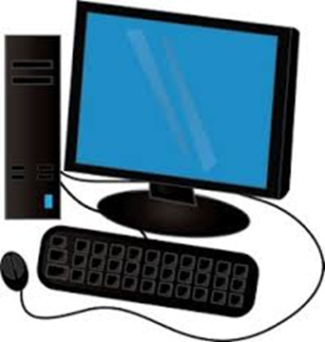

Accounts will log in using the Log In UI

Personal Computer



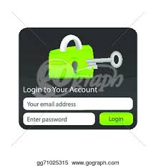

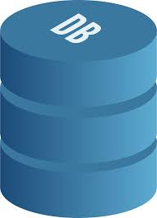



Connecting to Home Database for verification

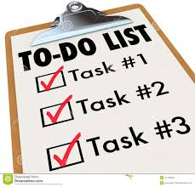

Log In UI

Home Database



Program will display all pending and completed tasks and messages from other account.

Creating, Updating, Deleting Tasks and Sending messages from other account

**IPO Diagram**

Output

Process

Input

Ou

* task list
* messages to the other account
* notification text message
* insert user credentials
* enter user information
* Input, add, delete and modify tasks
* Organize tasks
* Generate message
* user accounts
* user profile
* task
* message

**Flow Chart**

**YOU HAVE AN ACCOUNT?**

**INSERTING VALUES IN DATABASE**



NO

YES

**LOGIN**

**HOME DATABASE**

**MAINUI**

**ASSIGN TASK?**

YES

NO

**ENTER MESSAGE**

**COMPOSE**

**A MESSAGE**

**DELETE**

**MODIFY**

**ADD**

**DELETING TASK IN DATABASE**

**MODIFIED TASK IN DATABASE**

**ADDING TASK IN DATABASE**

YES NO

**Research Methodology**

Home database is focused more on Task managing system that helps the user in recording, reviewing and etc. their works without neglecting anything. As of that, the following are the methods of what this system will do.

1. The program starts with a little introduction in which it will make the user be sure if this is the right application they want to be on.
2. Having multiple users in a single application will be troublesome and may cause the multiple user’s application part’s unorganized, therefore the next frame will ask for the user’s credentials which correspond to their made accounts. It is indeed the login interface, which will guide the users to easily determine their specified tasks within their respective accounts.
3. All users are mandatory having accounts to make the program’s information organized and also for the users to have a privacy as well; so a registration frame will be held on if ever the user doesn’t have its own account which is containing the user’s credentials and many other information about them. This project was merely focused on the people inside a single home therefore there will be asking of identifications (parents, child, individual) in this part of frame.
4. Within the starting applications was the main frame which consist the main objective of the project – the task managing. At this part, the users can now manage their tasks according to their wants. To be precise, the users can add, delete, modify and if the task was done they can turn the task from ‘working on’ to ‘complete’. As of what the past methods told, there are identifications in every user; then those identifications have their own uniqueness within their respective accounts. For an instance, if the user is a parent on his/her account, they will have an additional job that they can do like giving a command to his/her child if there is any. While in the child’s account part will have the account viewer in which they can view other accounts that has been linked with theirs. And lastly the individual that can freely link to other account for they was a single persons.

**Scope and Limitations**

The program being a task management system, can perform basic task functions such as adding, deleting, updating, and mark tasks as complete. This task management system is connected to an account database which will allow other users to assign tasks to other users, and those users can view the tasks given to them but a user can also assign a task to him or herself. Moreover, the parents can message their children in the case that they want to say something other than the task. The program can organize and keep track of the time of those tasks and will have additional features such a dashboard that will update the user on important notifications such as almost due tasks, a biodata which you can view the important user info in the program but it can be edited, a calendar to view, current date and time. The program will not be able to send messages with more 100 characters to keep database efficiency in handling the data. The program will not be able to store attachments like photos since because such feature require cloud connection which requires subscription.

**System Screenshots**

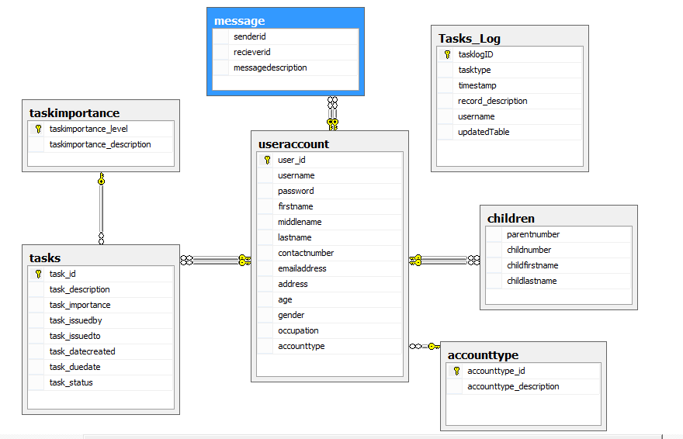

This is the database diagram for our Home Task Management System using Microsoft SQL Server. Our database is composed of 7 tables. The main tables that we work with in order for the system to perform its major functions are useraccount, tasks, and children. Useraccount is where we get the user’s account information as well as their account type which will specify whether the user is a parent or an individual. Tasks is where the users or parents more often will assign tasks to their children but an individual can also assign tasks to him or herself. The Children table is necessary because this is where a parent specifies who the children of the parent are and we made it into a separate table because not all of our users are children in their household.

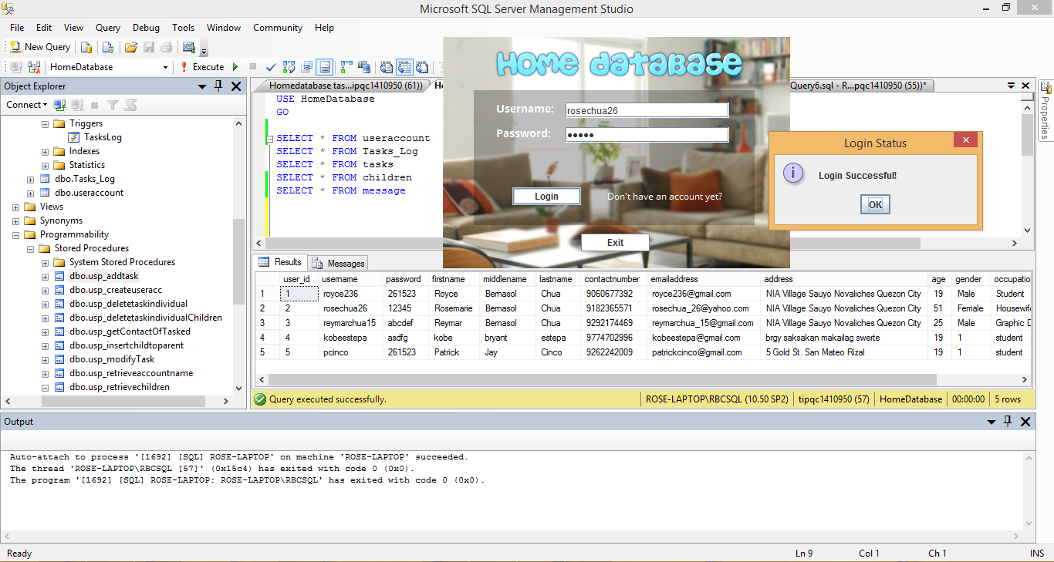

The system starts with a login window that will authorize the login and then give access to the main window when the credentials entered match any username and password inside the database like with the rosechua26 account. rosechua26 is a parent account so she has the ability to assign tasks to any children under her account. The stored procedure we used can be seen on the left along with the trigger.

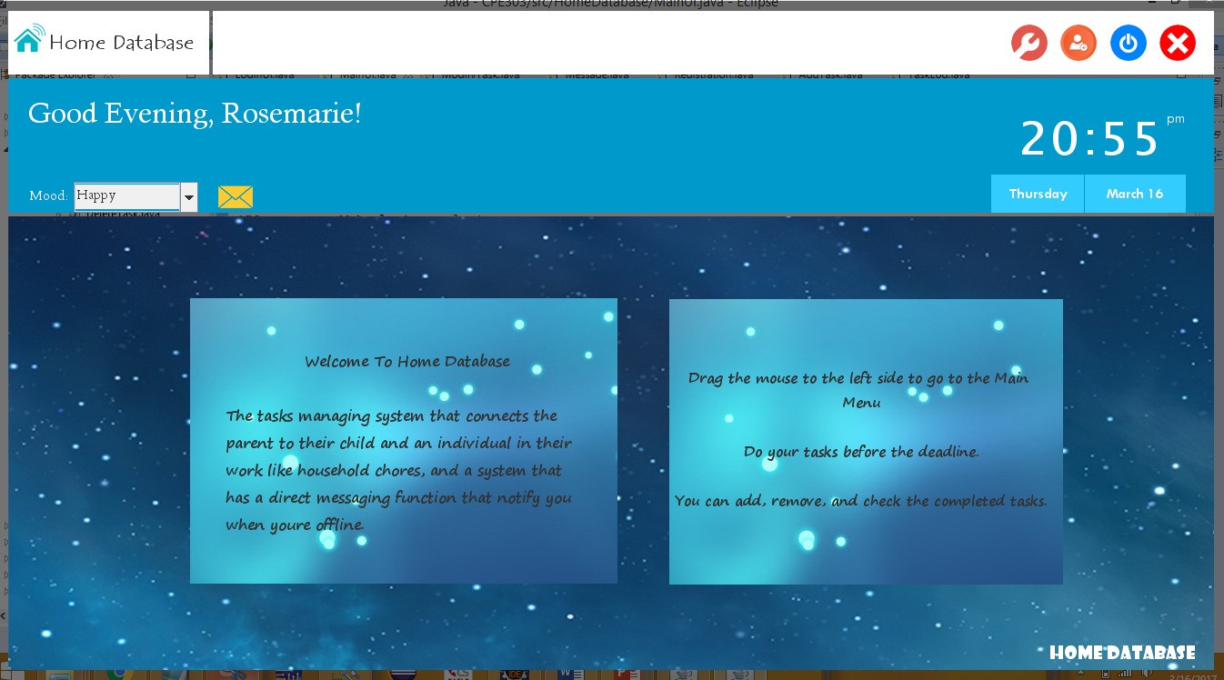

When the user has logged in to his or her account successfully, an introduction screen would be displayed along with a greeting to the user “goodmorning, goodafternoon, or goodevening” depending on the date which in this case the time was 20:55. The upper right portion has 4 buttons which are task log, the add child for parent, log out, and exit buttons. The ability to set mood is just an extra feauture. The message icon gives users the ability to message one another inside the program.

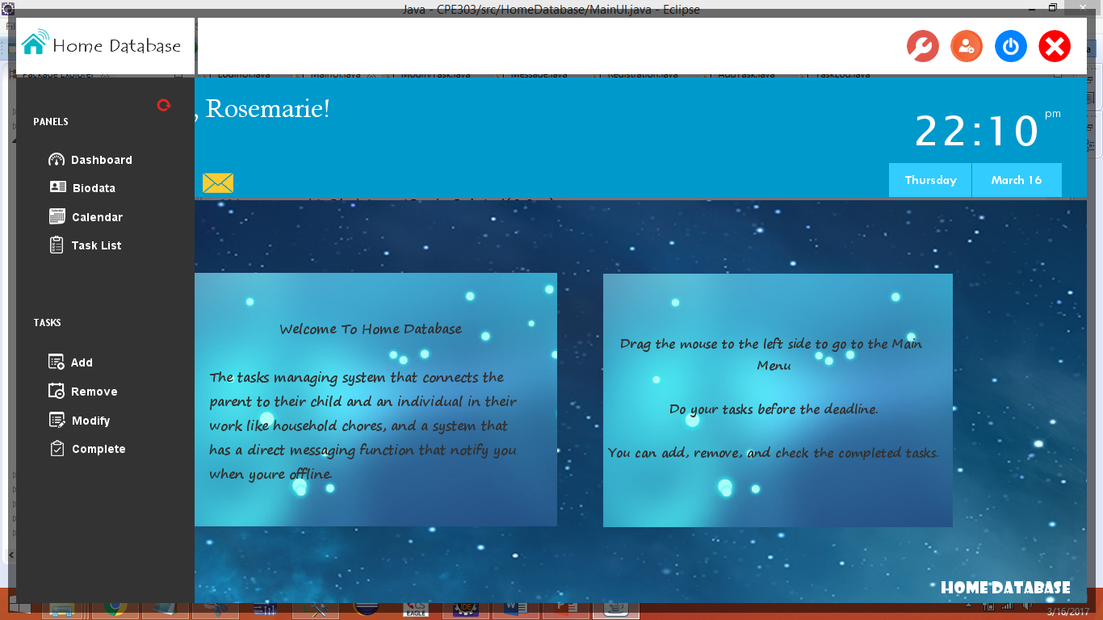

Placing the mousebutton to the left most part will show the main menu where the logged in user can see some panels showing his or her biodata which contains user information, a calendar which displays a small calendar for the user, and the task list where the user can view the task that was assigned by himself or herself or to his or her children if a parent. In the task panel, the user is given the ability to add, remove, modify, or complete a task. The next group of images will show the add task function.

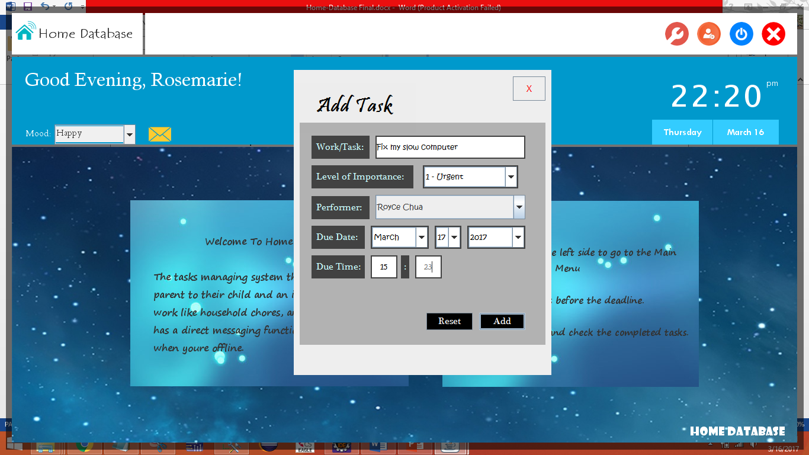

This screenshot shows the add task window where the user or in this case Rosemarie a parent will give a task to one of her children Royce Chua which is “Fix my slow computer” that is due March 17, 2017 with 3:25 am as the deadline for sample. If this codes executes correctly, a text message should be sent to the contact number provided by Royce Chua. The message will contain the task and the due date given by Rosemarie.

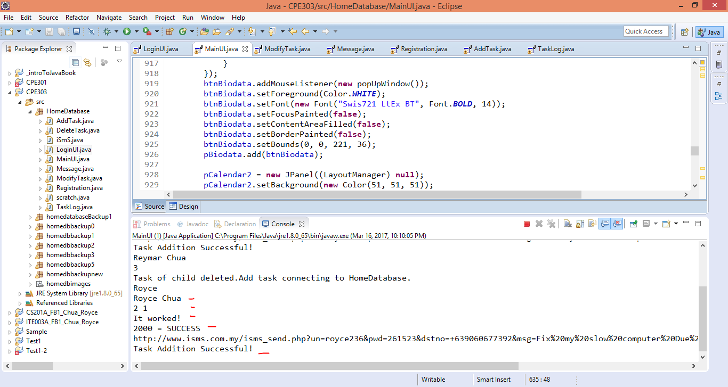With regards to my java program, the system out statements show the db operation was indeed successful and java has sent a text message to Royce Chua’s phone as a result.

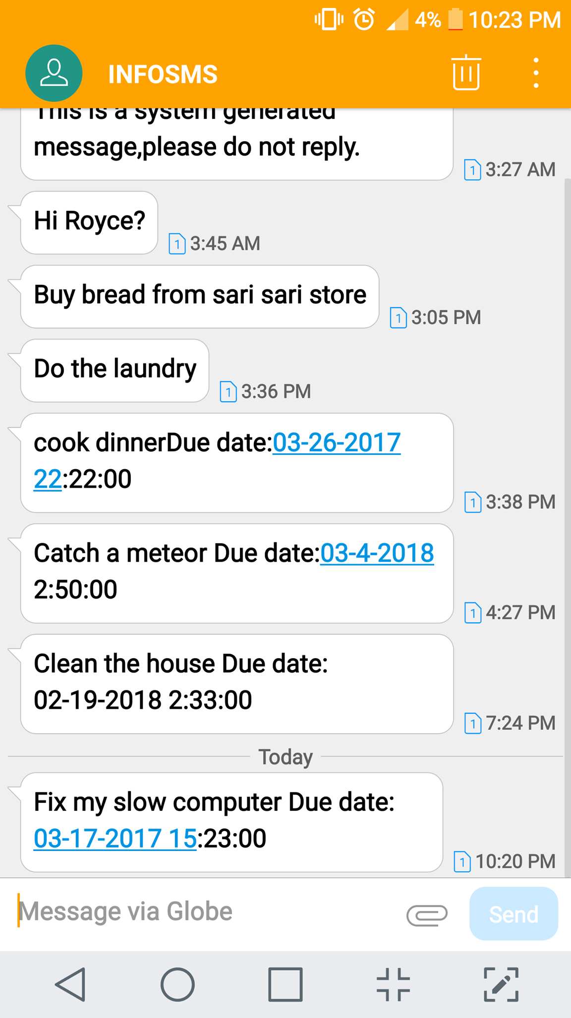

This is the task assigned by Rosemarie Chua to Royce Chua on the Java Program, the previous messages show our process of trial and error with the codes and the content of the text message.

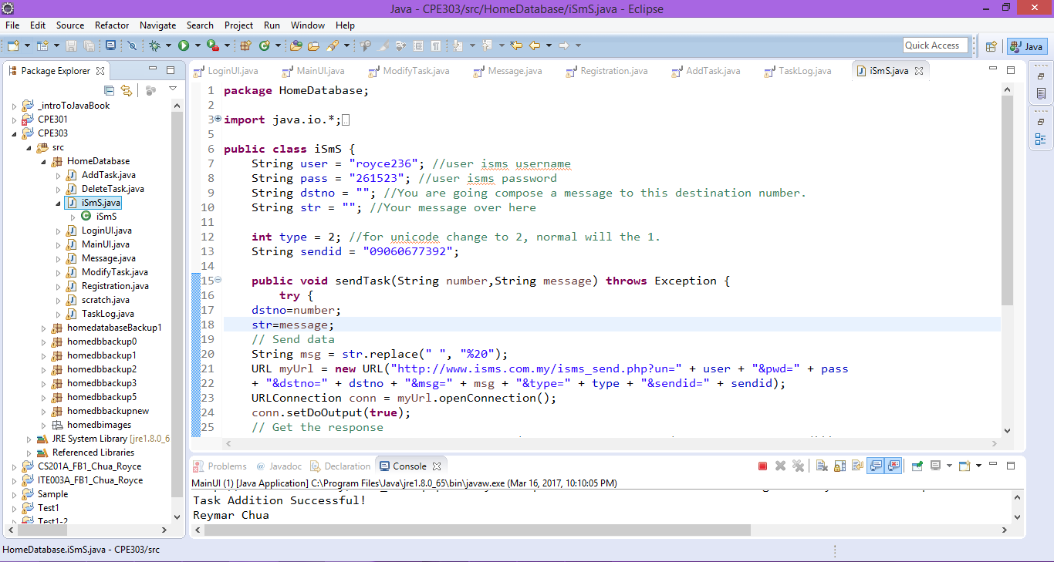

For the Java program’s ability to send a text message to a cellphone number, we used the services of a SMS Gateway API called iSmS which is a local SMS Gateway provider here in the Philippines. The codes function is very simple to explain because all the java code does is it performs an http request as seen in the myUrl string with the following parameters here we can see my user credentials on iSmS and the destination number dstno and str which is the message. When it performs builds this string, it will send it to the website using my credentials and their API will begin to do their thing and all it requires of our program is credits which comes at an affordable price.

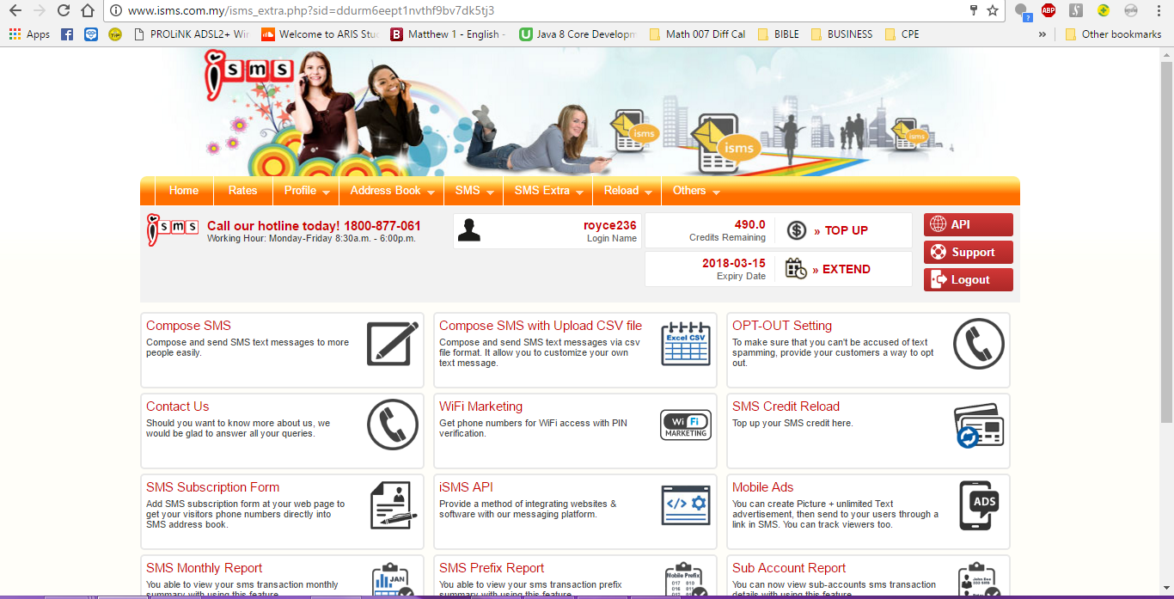

This is the website of ISmS, the SMS Gateway provider that was used, it can be observed that the java program mainly acts on my behalf to send a text message through their website. The text costs 1 peso per text.

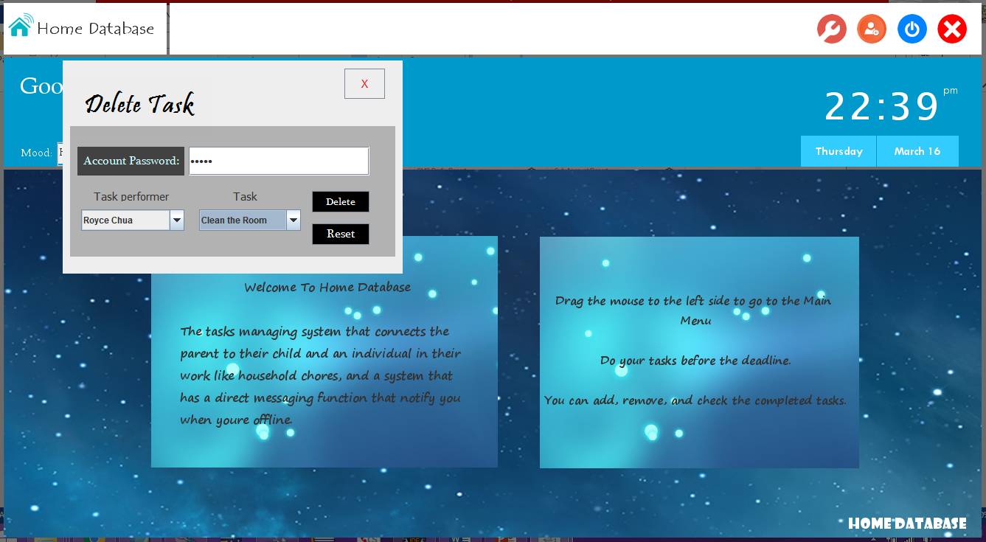

Suppose the user wants to cancel a certain task that he or she assigned the Delete task from the task panel can be selected. The delete task JFrame provides ease of use for the user because if Rosemarie the parent for example wants to delete a task given to Royce all she has to do is find Royce in the combo Box and then all the corresponding tasks given to Royce or any other user will appear if selected on the task performer comboBox.

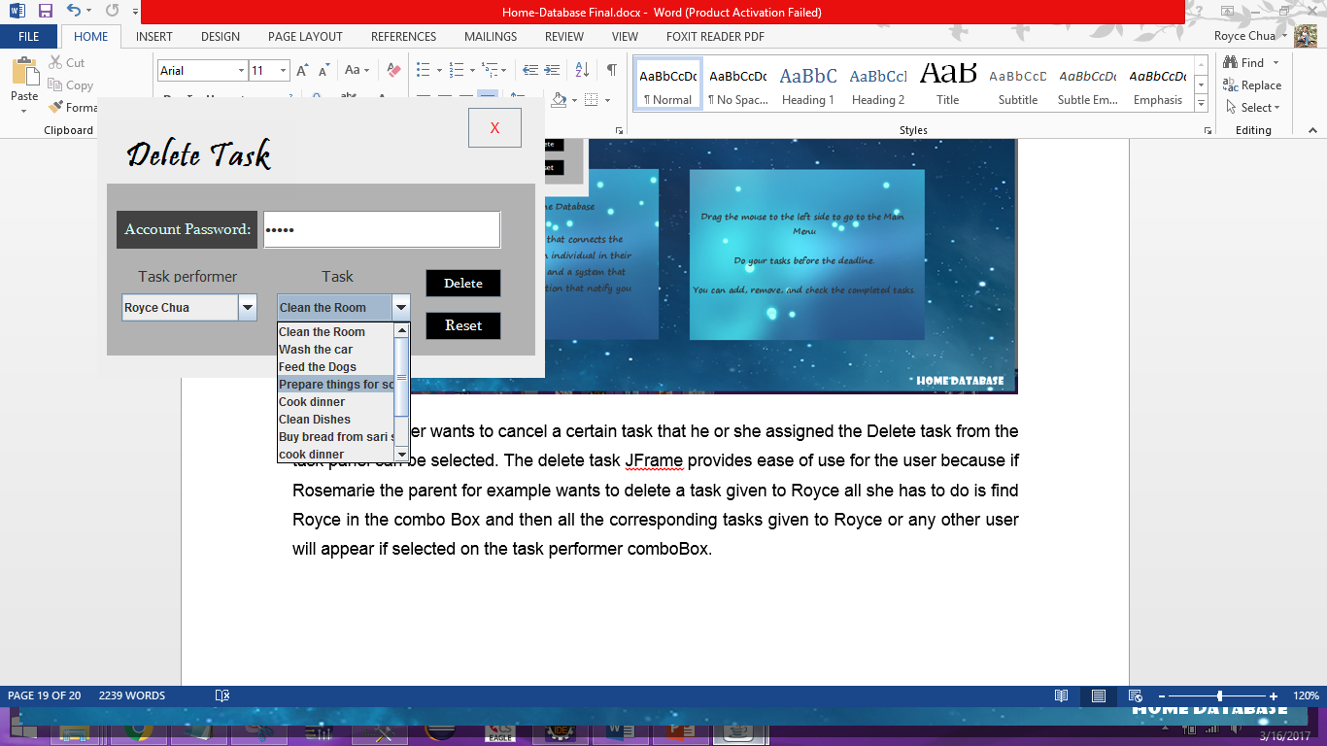

This provides ease of use on the Rosemarie’s part and once chosen and the correct password is given the task will be deleted.

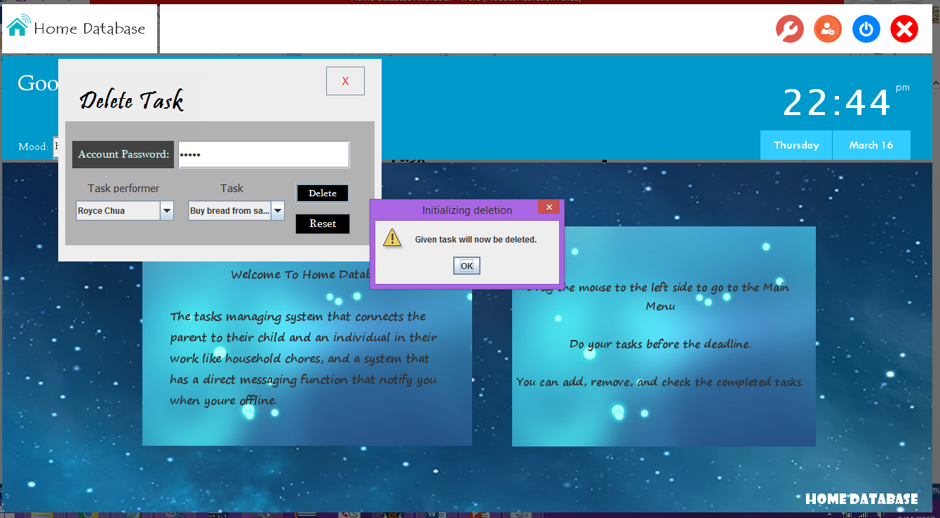

The java program has indicated that the task has been deleted but to be sure that it has, the task_log window can be used from the program itself.

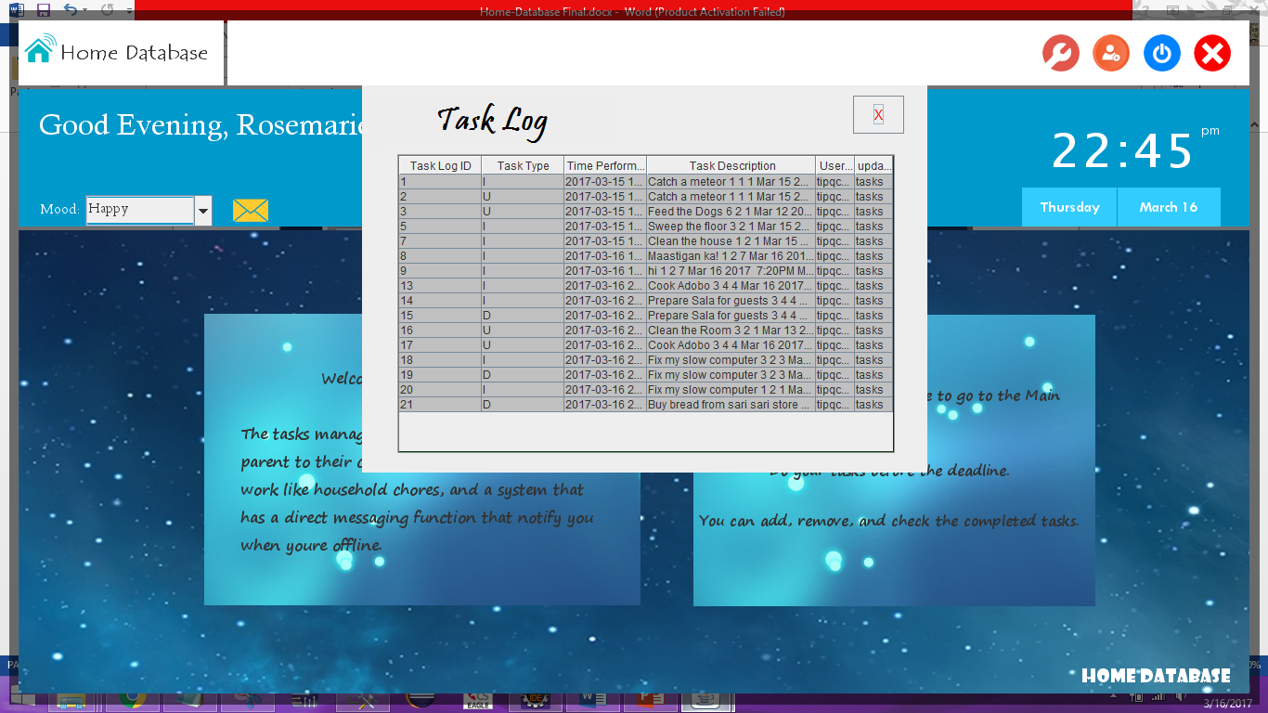

So clicking on the task log button, it can be seen from the last that the buy bread was indeed deleted indicating the task type as D. This task log is the exact task log we can view on the MS SQL server management studio.

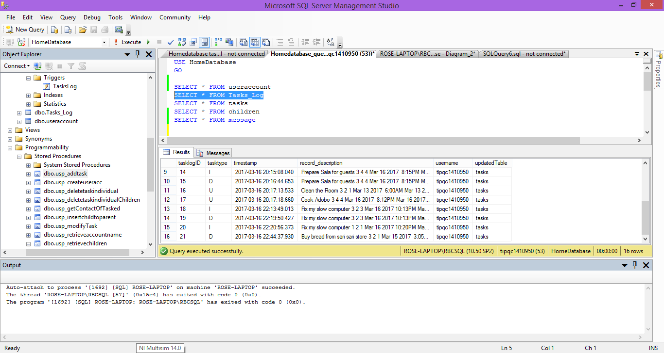

The java and sql management studio display the same thing indicating that the task_log is working properly and is connected to java.

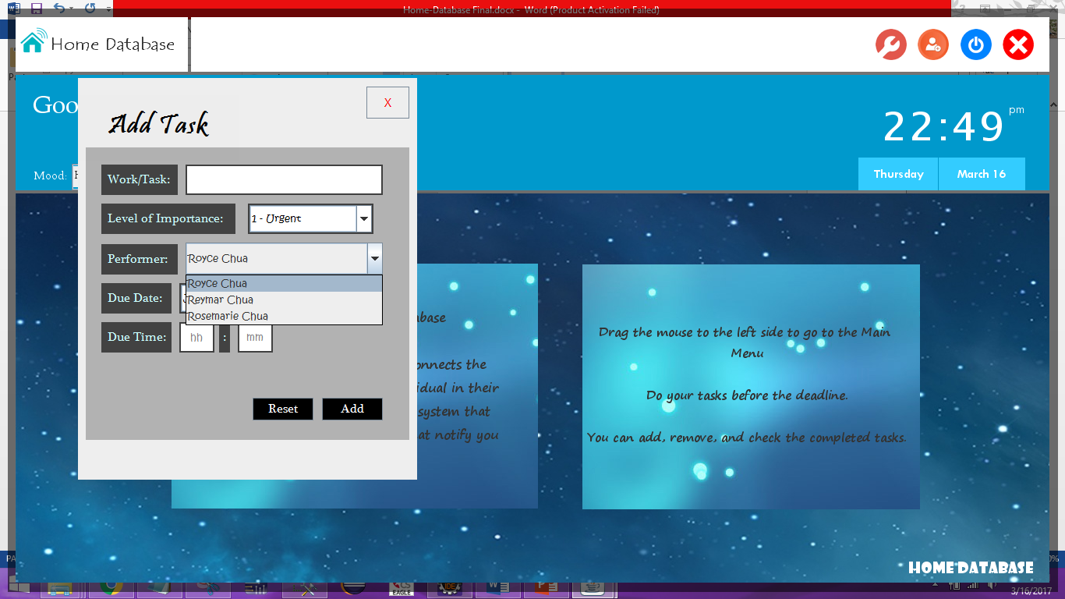

Suppose that Rosemarie had another child named Kobe, Rosemarie can instantly add Kobe using the add child button on the upper right.

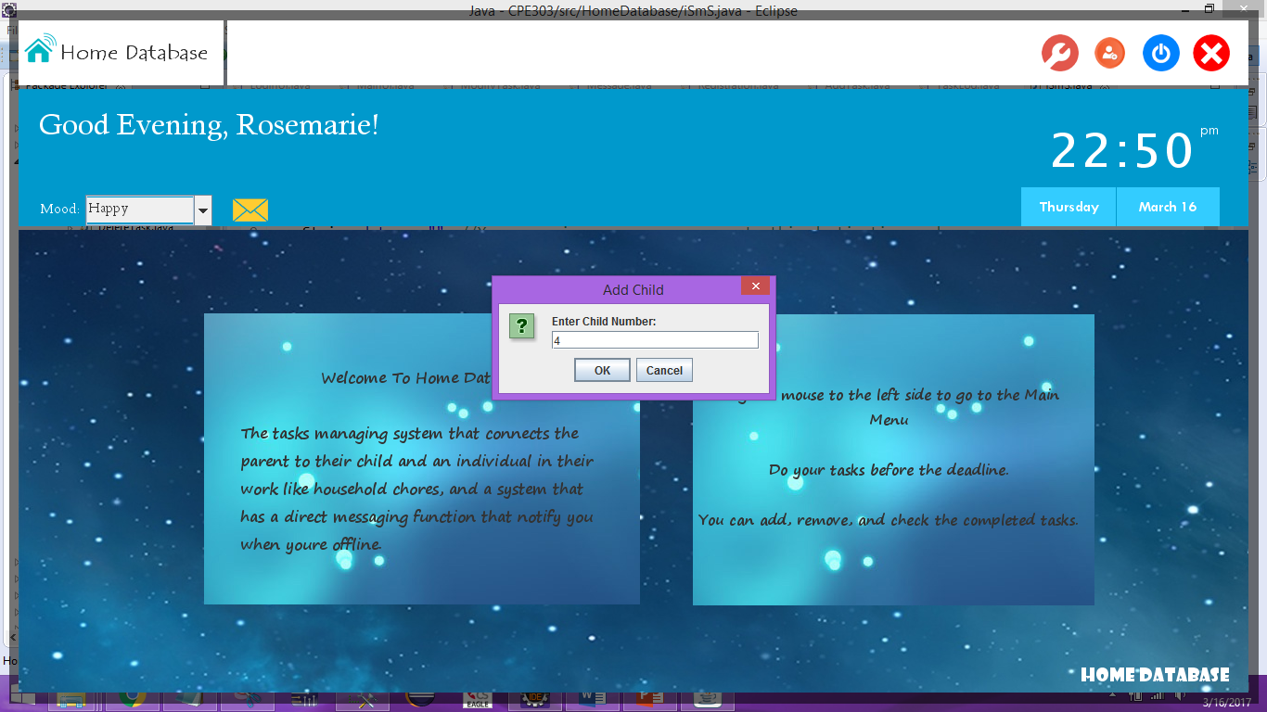

The child number can be known when the parent first logs into kobe’s account inside the biodata the user can see his or her userid.

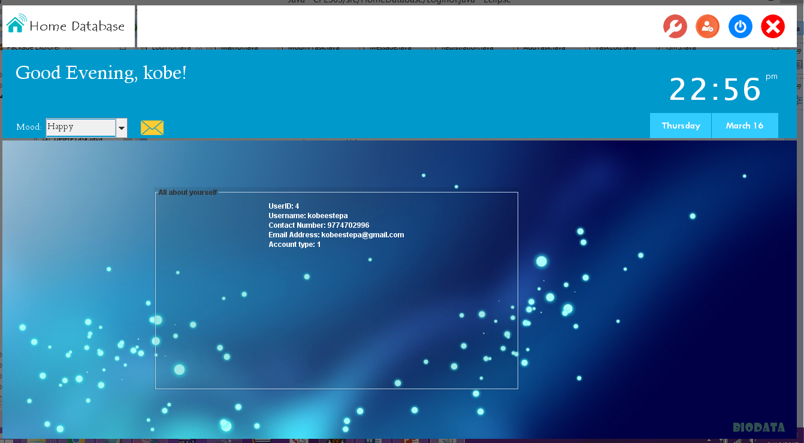

Kobe’s userid can be seen on the biodata window.

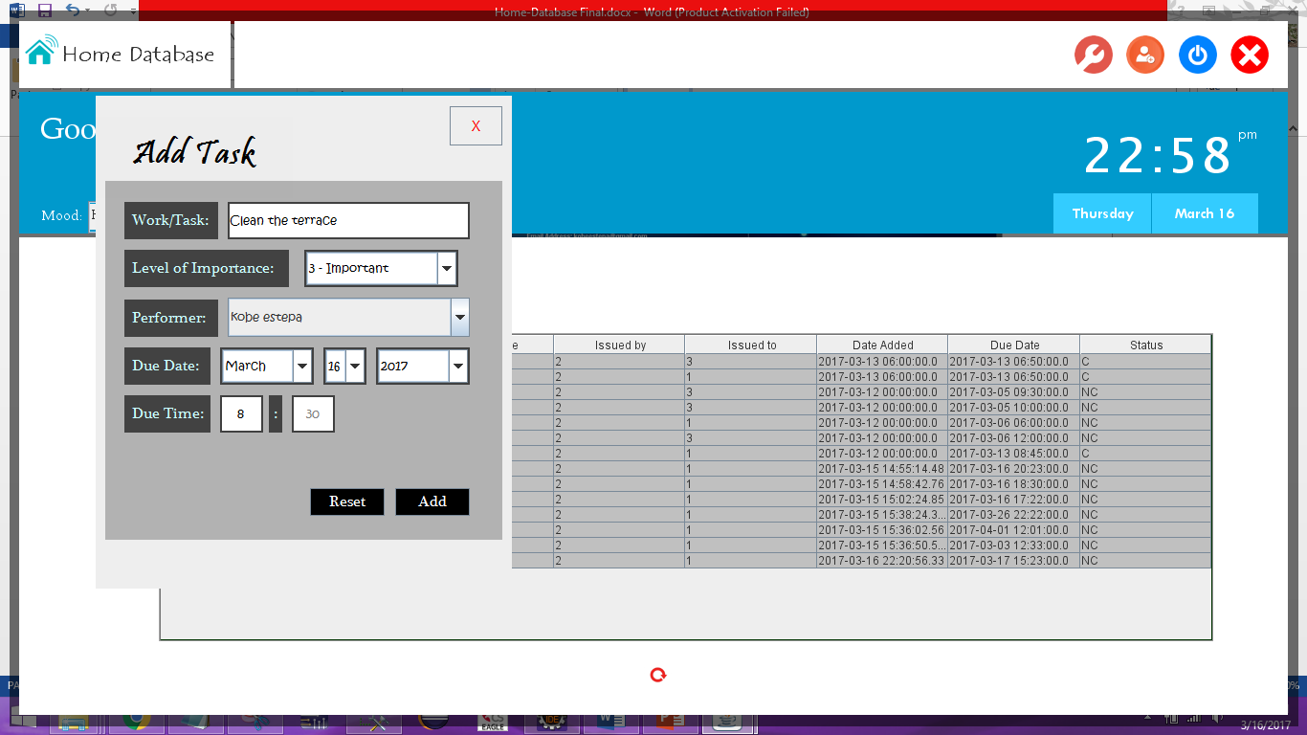

Now that kobe has been made a child logging back in to the Rosemarie account we can see that Kobe Estepa readily appeard on the comboBox.

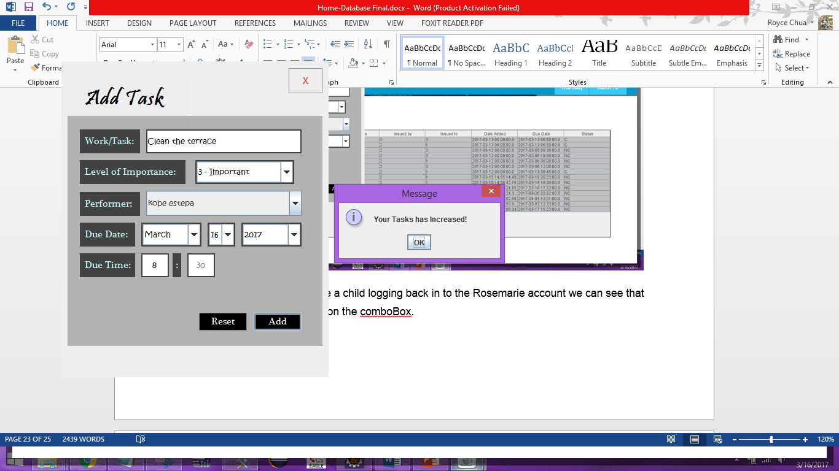

To verify that Kobe can view it on his account, we will log him back in.

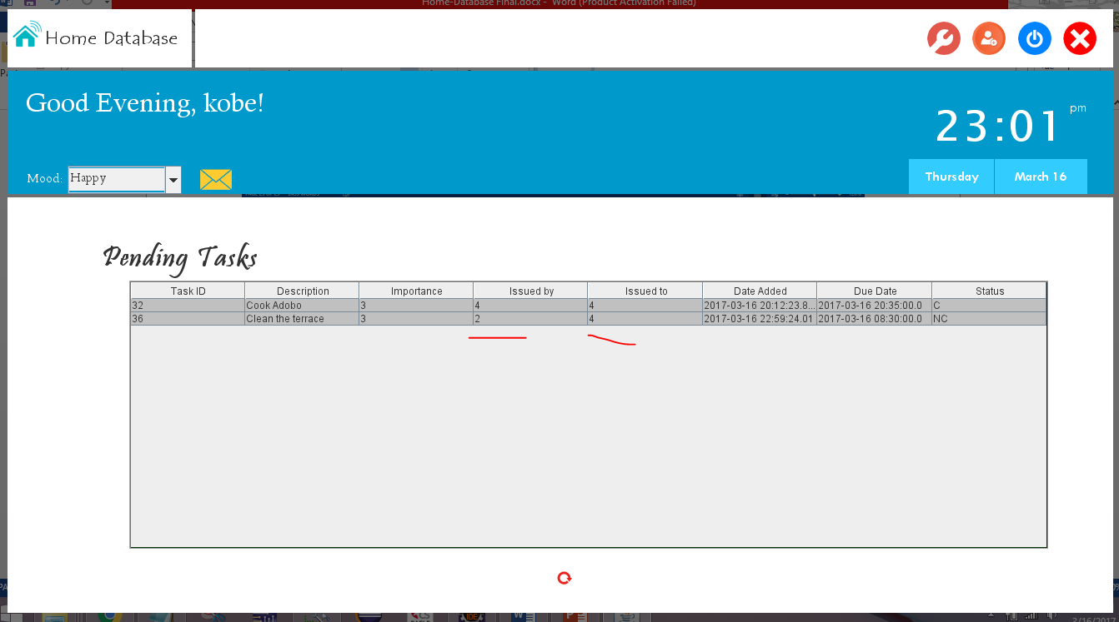

It can be seen that kobe can easily view it on his account once the command is given along with the text. Besides that we can also see a command issued by Kobe to himself verifying that as an individual they can give commands to themselves.

**Recommendations**

We recommend that for this system perhaps a chatting system can be implemented in addition with this existing one because in our messaging feature it is limited only inside the local network but in case we decide to put it on the internet, it would be better if we would use a chatting system feature. Also we recommend that the calendar could be coded to display dates and reminders like in Schoology. Lastly, we highly recommend that future projects like ours requiring SMS messaging could also make use of such API and other API’s alike for their programs in order to make their system more realistic and compete with real world standards.

**Conclusions**

In this project, we have come to conclude that integrating Transactions, Stored procedures, with user-stored Functions and Triggers automates the repetitive tasks we do inside the server causing program management as well as database management to be much easier to work with and troubleshoot in case of problems or errors rather than repeating queries inside the java program which makes the source codes look like a “spaghetti code”. We have come to conclude that being familiar with programming makes learning stored procedures, stored functions, triggers and transactions easier because we can see it like how we construct a method like in Java so really there is no difference between Java and SQL in terms of logic and algorithm making, the difference lies in their syntax and uses. Lastly, we have come to conclude that in the real world, Database Systems will always have Stored Procedures, Stored Functions, Triggers, and Transactions so being competent in using them and diagnosing them will be an advantage for us if we ever pursue a career in being a database administrator.

**Lessons learned**

In this project, we have learned first and foremost how to plan more effectively as a team, how to plan out a database more efficiently rather than typing and typing without thinking, how to integrate our learnings from database management systems 1 with new techniques in database management systems 2 such as Stored procedures or Triggers. We also learned how to construct more advanced queries unlike from DB1, we learned how to call stored procedures on Java, and lastly and our most unique learning is the knowledge on how to text a cellphone number by using an SMS Gateway provider such as iSmS using https request method. With regards to our work ethics, we learned to complete our objectives or what we proposed when it comes to the project as much as we can because in the real world people expect their developers to follow on what they have proposed.